Objective Complement

✅ What Is an Objective Complement?
# Source: Chatbot (GPT-4-turbo) at [8/4/2025]
An Objective Complement (also called object complement) is a word or phrase (usually a noun or adjective) that follows and modifies or renames a direct object.
It tells what the direct object has become, what it is, or what is done to it.

🔸 Key Features:
# Source: Chatbot (GPT-4-turbo) at [8/4/2025]
- Comes after the direct object.
- Can be a:
  - Noun → renames the object
  - Adjective → describes the object
- Works with certain verbs like:
make, name, call, elect, consider, find, paint, appoint, think, declare, judge, choose.

🔸 Structure:
# Source: Chatbot (GPT-4-turbo) at [8/4/2025]
Subject + Verb + Direct Object + Objective Complement

🔸 Examples of Objective Complements:
# Source: Chatbot (GPT-4-turbo) at [8/4/2025]
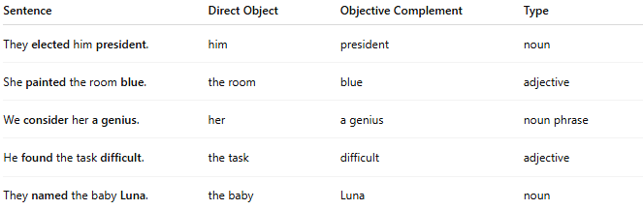
Sentence | Direct Object | Objective Complement | Type
They elected him president. | him | president | noun
She painted the room blue. | the room | blue | adjective
We consider her a genius. | her | a genius | noun phrase
He found the task difficult. | the task | difficult | adjective
They named the baby Luna. | the baby | Luna | noun

🔸 How to Identify an Objective Complement:
# Source: Chatbot (GPT-4-turbo) at [8/4/2025]
- Find the direct object.
- Ask: Does the word or phrase after it rename or describe it?
- If yes, it’s likely an objective complement.
✅ Test: “They elected him president” → He became president → OC ✅

🔸 Not Objective Complements:
# Source: Chatbot (GPT-4-turbo) at [8/4/2025]
Don’t confuse with:
- Indirect objects (they get the action for/to whom something is done).
- Prepositional phrases (which don’t rename/describe the object directly).

